5.82: We take the upward direction as positive. The explorer’s vertical acceleration is 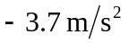 for the first 20 s. Thus at the end of that time her vertical velocity will be 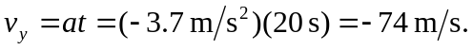 She will have fallen a distance
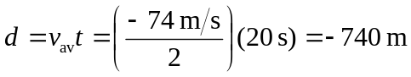

and will thus be above the surface. Her vertical velocity must reach zero as she touches the ground; therefore, taking the ignition point of the PAPS as 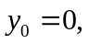
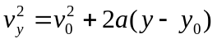

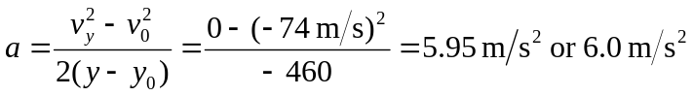

which is the vertical acceleration that must be provided by the PAPS. The time it takes to reach the ground is given by

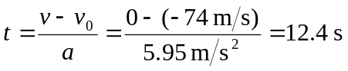

Using Newton’s Second Law for the vertical direction

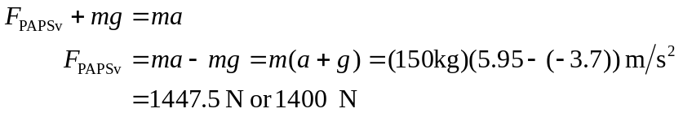

which is the vertical component of the PAPS force. The vehicle must also be brought to a stop horizontally in 12.4 seconds; the acceleration needed to do this is
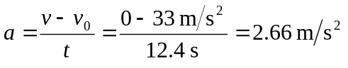
and the force needed is or 400 N, since there are no other horizontal forces.

